EX. NO: 03 Design a simple topology using Cisco Packet Tracer
DATE: 23.07.2026

AIM:
To Design a simple topology using CiscoPacket Tracer
TRACER simulator for HUB, SWITCH and BOTH.

1. From the network component box, click and drag-and-drop the below
components:
a. 4 Generic PCs and One HUB
b. 4 Generic PCs and One switch
2. Click on Connections:
a. Click on Copper Straight-Through cable,
b. Select one of the PC and connect it to HUB using the cable. The link
LED should glow in green, indicating that the link is up. Similarly
connect remaining 3 PCs to the
HUB.
3. Click on the PCs connected to hub, go to the Desktop tab, click on IP
Configuration, and enter an IP address and subnet mask. Here, the default
gateway and DNS server information is not needed as there are only two end
devices in the network.
Click on the PDU (message icon) from the common tool bar,
a. Drag and drop it on one of PC (source machine) and then drop it on
another PC
(destination machine) connected to the HUB.
4. Observe the flow of PDU from source PC to destination PC by selecting the
Realtime mode of simulation.
5. Repeat step #3 to step #5 for the PCs connected to the switch.

Output:
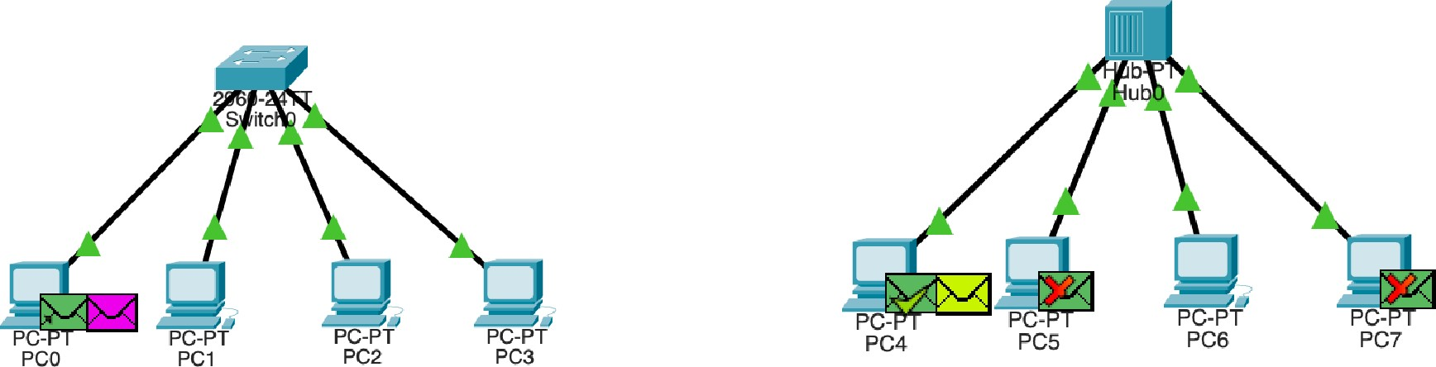

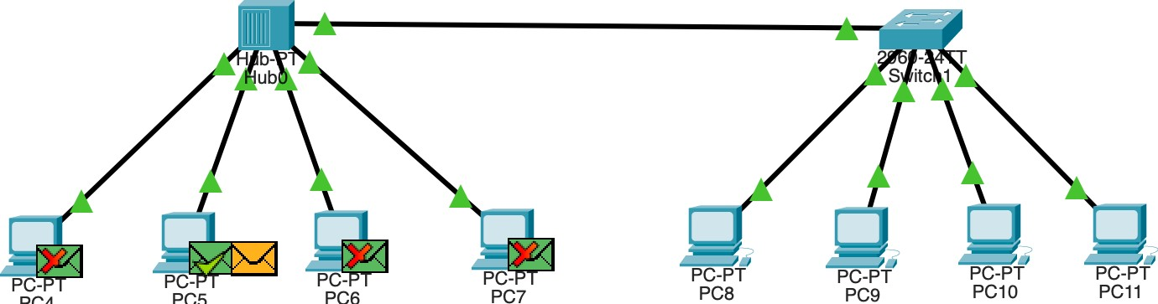
PC4
PC5
PC6

RESULT:
A simple topology using CiscoPacket Tracer is Designed for Hub, Switch.

